Executive Summary
Yardstick Golf Indoor Golf Center Business Plan

"You do not need to request a share:
copy to your drive or download to edit"

Running an indoor golf business involves creating a facility where golfers play rounds on a golf simulator that projects an image of a course and uses sophisticated sensors to depict the real shot in a virtual environment. There are many of these businesses existence, and success turns on 4 basic items:

- Managing start up costs
- Keeping simulators fully rented
- Add on revenues from food and beverage, merchandise or lessons
- Controlling operational costs

This business plan will address each of these four items and a bit more.

HD GolfPlex (working name) is a high end facility incorporated in City, State designed to provide entertainment via high definition full swing simulation golf. The golfing entertainment will be complimented with good food, beverage, golf merchandise and attractive surroundings.

Our goal is to provide the (City) golfer, and eventually golfers across the US, with an enticing alternative to outdoor golf when time, weather or proximity prohibit traditional play. We provide a realistic golf experience in a comfortable environment, turning the local golf season from 180(?) days to 365 days per year.

Each of our (6) state-of-the-art golf simulator units will be linked to allow competition and record keeping. Customers will be given the option to register a user name with the center and keep track of their scores, see how they stack up with other users of the system, and track their performance throughout the year. Game software will also allow for tournaments to be played with real time scoring and statistical breakdowns of the entire field. It will give customers a quantifiable depiction of their golf game and will allow them to improve their skills.

A group of four can play 18 holes in about 2 hours on a wide variety of courses for only about $25 per player. Compare this to a 4-5 hour round on a local golf course that can cost anywhere from $45-$90 per player depending on where you play.

Managing Start Up Costs

Depending on the size of your facility and the amenities, start up costs can be significant. Many indoor golf centers start small and grow as they see their revenues grow. Others take a decidedly more ambitious approach and build a premium facility from the start. Choose a path that makes sense for you, your budget and matches your clientele.

Use this section to talk about your start up costs. Some of the information below should help you lay out your plans for start up costs.

One of the major expenses will include the cost of the golf simulators. For a commercial operation, these can run as little as $15,000 or as much as $60,000. Price will depend on a host of factors, software features, number of courses and size of the system. Some facilities mix the simulators, purchasing several basic ones and one or two high end systems. This enables them to offer premium services without the extra start up expense.

Another start up expense will be facility costs. In most cases, facilities will be leases, but a few do choose to buy / build a facility. In the event you are doing a commercial lease, there will likely be build out expenses to suit your specific design. It may make sense to get help from a commercial real estate pro to help you negotiate these as part of your lease. Careful selection of your location using research about what drives golf center revenues will also ensure you pick a good location without paying too much. Location selection is covered later in this document.

The types of complimentary services you chose offer will drive other start up expenses. If you are going to do food and beverage, you will have a few other costs. Licensing for food and beverage will be one such expense. Building out a kitchen will be another. Even a low end kitchen with used equipment will run over $20,000. Don't forget about marketing, recruiting, website, network and signage expenses.

Take a look at all your expenses and figure out which ones are the keys to your success. Be sure to get the right equipment on the items that are critical to your success and perhaps defer those that are not as critical until after you have a strong revenue stream.

Keeping Simulators Fully Rented

Use this section to talk about your plans to keep simulators fully rented. Some keys or ideas we’ve discovered include.

The first key is to really know which customers you are targeting. A family entertainment venue might not be well suited to attract customers mostly focused on instruction and game improvement. This extends to the additional services you plan. Going after high end customers in a low end warehouse, may not be a great fit either. Make sure your center matches your target audience and you have an appropriate business name and logo.

The second key is in sizing your facility correctly. If you have too few or too many simulators, you’ll either be losing revenue or having simulators sit idle for long stretches of time. Our Indoor Golf Center Model contains many factors to help determine your expected traffic. Many centers look for a location where they can start small and add capacity as needed.

Assuming you’ve picked the right location and appropriately targeted your facility, the next step is in building awareness and driving play. Good signage on your facility is important. Make sure your sign is easy to see, read and understand. There are some great possible names for indoor golf facilities, but make sure they let potential customers know what you do.

Once you open, there are a host of marketing activities to help keep your center full. Some to discuss in this section include:

- Website and Social media strategies to get your name out there
- Press releases and media coverage
- Setting up leagues and tournaments
- Creating memberships or multiple play bulk purchase options
- Targeting seniors or juniors during work hours
- Being open hours when people want to play (after work, weekends)
- Frequent player cards
- Merchandise demo days
- Charity or corporate events
- Private parties
SWOT Analysis
A strengths, weaknesses, opportunities and threats section is helpful to think through your business strategy. This is a small example of the kinds of things you should consider.

Strengths – A key strength is in the product delivered by HD GolfPlex. Our simulators are top of the line and provide a realistic golfing experience with very accurate shot simulation. Our facility is also a key strength in that it is high end and provides key amenities local patrons seek in both golf and entertainment. Our staff is friendly and helpful. A final strength is in developing a strategic plan focused on customer centric operations and an information-based marketing strategy. There are a number of golfer oriented marketing databases we can leverage while we build our own data.

Weaknesses - A main challenge will be scheduling to keep the center full. Weekday business hours and weekend days with great weather are likely to be off-times for the business and show a lower utilization. Leagues, corporate events, and other creative ideas and activities will be critical to keep the place full all day, every day. Our other weakness is the technological complexity of the simulators. We’ll be reliant on the manufacturer for service or will have to develop in house technical talent for maintenance and repair of the simulator units.

Opportunities – One opportunity is to partner with local golf courses and clubs to offer offseason memberships. Merchandise sales and club fitting is another opportunity – we could leverage local distributor reps to do demo days, have demo and fitting sets on site and offer extended fitting and playability sessions. The simulator units also have the capability to display advertising, but feedback from the vendor indicates this is best used for in store promotional activity versus seeking ad revenue. A final opportunity would be in the hiring of or partnering with PGA trained teachers to provide lessons and coaching for clients. Research so far indicates that teachers keep lesson fees, so this would just be a strategy to keep the simulators running. One other idea is to focus more on video game or private sporting party clientele in the golf offseason as the projectors can be attached to a receiver to show TV or video games. Could target alumni groups to show / host their football games.

Threats – The main threats are competition or issues with the simulator manufacturers. Competition could be from other similar businesses or Sports Bars as they could add a simulator. There are (number) of Indoor Golf facilities in the area so far. The closest is (#) minutes away. Competition from Sports Bars is a possibility as is competition from golf retailers like Dicks or Golf Galaxy, both of which have a single simulator for club testing.

Revenue Forecast
Forecasting financials is an important part of the business plan. This is where you lay out assumptions that drive revenue based on your services. This is another example you can modify to your specific needs.

The revenue forecast is most heavily influenced by the number of rounds played and the rates we charge. Based on the hours we plan to be open and with 6 simulators, HD GlofPlex has a total of 468 simulator hours per week capacity. Peak season will be November – March as they are colder months with shorter daylight hours.

Research indicates two pricing models for simulator use. One is hourly and the other is per round. Charging $30 per player assuming an average of 2.5 players per round at 1.5 hours for 18 holes yields an hourly rate of $50. The typical simulator rate is in the $35-$40 an hour range. This revenue forecast assumes $40 per hour for simulator use.

Conservative Simulator Revenue Forecast
Based on 6 simulators, HD GolfPlex has a total of 468 simulator hours/week capacity. Assuming the offseason utilization is about half the peak season, HD GolfPlex is forecast to generate ~$400,000 in simulator revenue in year 1. (The utilization rates below are place holders– real information on utilization rates can be found on our website)

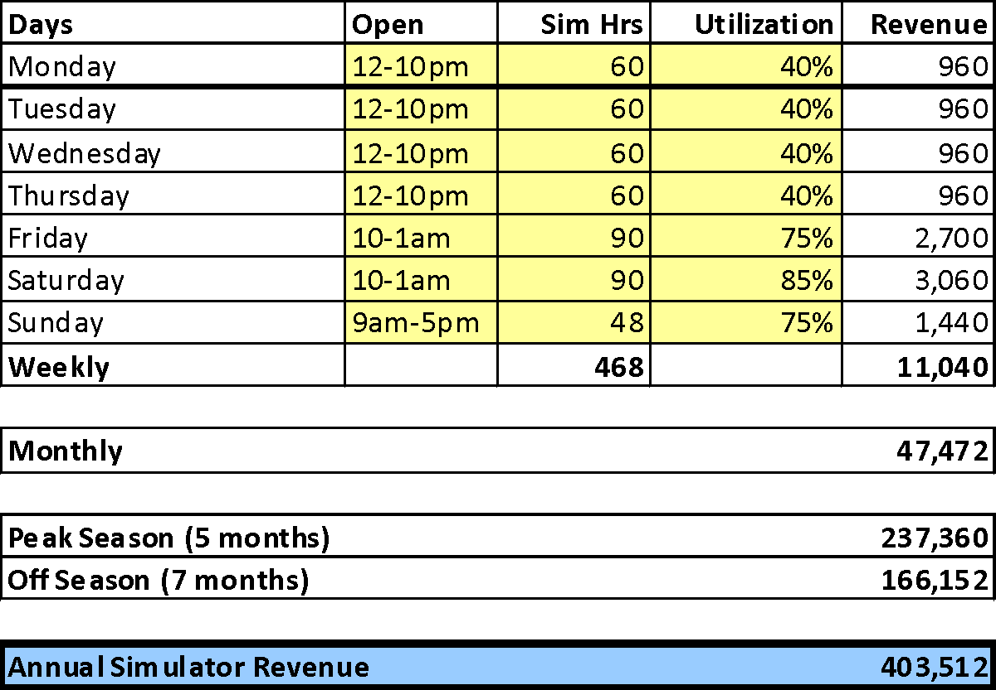

Conservative Food and Beverage Revenue Forecast
The food and beverage forecast will be based on an average tab per patron. The simulator revenue forecast equates to 17,500 players annually. Research finds an average sports bar tab between $12 and $20 per person. Assuming $12 per customer, food and beverage revenue is forecast at $220,000. (Real forecasts of food and beverage revenue for Indoor Golf Centers can be found on our website)

Other Revenue
There are several other revenue streams: league fees, merchandise sales, advertising, club fitting, tournaments, etc. These will likely be smaller than food and beverage, and without a basis for estimation, this model assumes 10% of simulator revenue, equating to $40,000 per year. (real data on other revenue is also on our website)

Total annual revenue projection for the HD GolfPlex with 6 simulators is $660,000 in year one. A three year revenue forecast assuming a 5% annual growth rate is as follows:

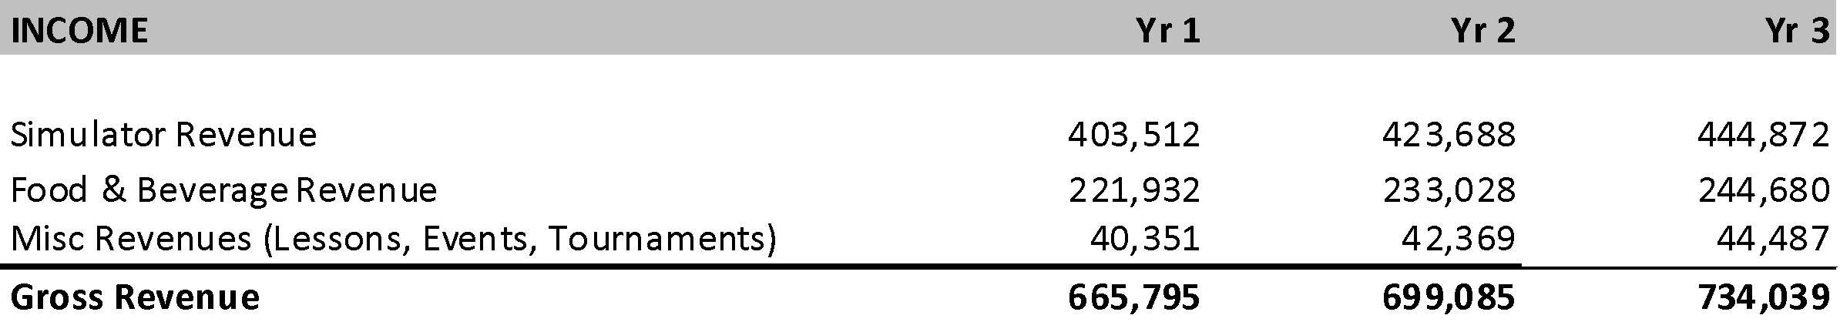

Expense Forecast
In projecting your financials, you also need to lay out costs. To be clear, it doesn’t hurt to cover start up costs again and visit operational expense expectations.

Expense evaluation will cover both start up and ongoing operational expenses. The primary start up expenses are for purchase of the simulator equipment, build out of the store location, furniture and kitchen equipment. These are estimates that vary by location. These need to be validated by checking on local rent, utilities, licensing, etc. 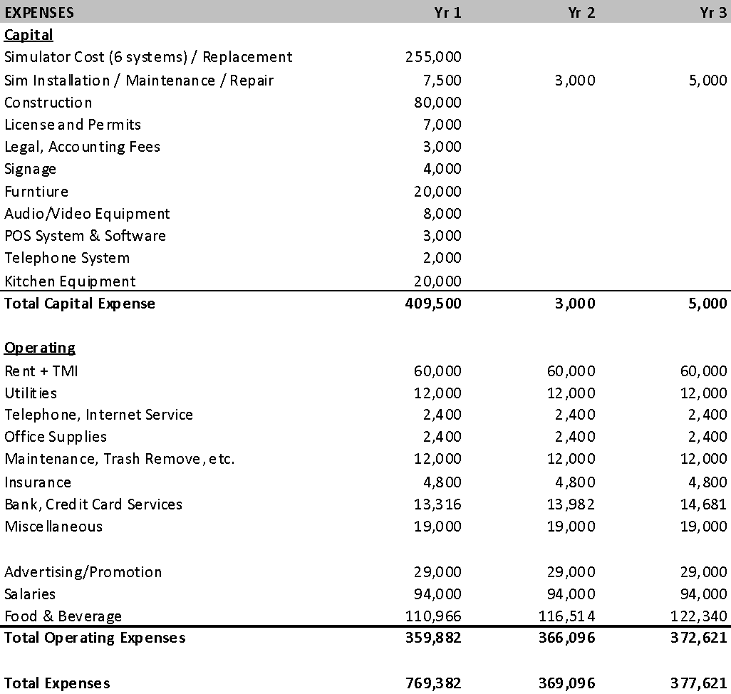

HD GolfPlex Store Location

Being in a good and accessible location that matches your target customers is a key to running a successful indoor golf business. Research on the indoor golf industry points to a few keys to determining the best location for your indoor golf center. It is also critical to make sure you are not paying too much for your location in order to keep your expenses in line. Based on our research, some of the keys to site location include the following:

Home Ownership:
The higher the proportion of home ownership there is in your target area, the more rounds of golf you are expected to be able to support. This means a higher percentage home ownership in the zip where you are locating, indicates a higher propensity for playing golf. In addition, the average home price tends to also help predict the volume of rounds played. The higher the average home price in a zip, the more rounds you can expect. Look for information on the web about your target zip code and see home prices, percent renters, income and more.

Number of golfers in a 10 mile radius:
Not surprisingly, the number of golfers in a 10 mile radius from an indoor golf center were strongly correlated with the number of rounds reported by that golf center. The more golfers in the radius, the better for your golf center. A great place to find this sort of information is from marketing list companies. They gather information on golfers from things like magazine subscriptions and website registrations. Some may provide you these numbers as part of the process to price a list and you can get the number without paying for the list.

Weather:
This probably doesn't help pick an area within a city, but can give you a sense of how viable a given city is for an indoor golf center. The higher the number of rain / snow days there are per year, the higher the number of rounds played. Indoor golf centers in the United States experienced as many as 156 days per year with rain or snow, while others had as little as 90 days. Centers on the high end of this range get more play.

Average Annual Daily Traffic:
I am including this as a probable driver of rounds played, as traffic data was somewhat difficult to get with enough precision to be confident in analysis. That said, with a high number of first time visitors during the first year of an indoor golf center business, it stands to reason that a higher volume of traffic outside a location would be better than a location with lower traffic. The traffic statistic in question is often called Average Annual Daily Traffic and most reports abbreviate it as AADT. You may be able to search for it on the web for your target area in question.

YARDSTICK GOLF
Hopefully you found this free business plan starter of value. We have much more to offer for current and potential Indoor Golf Center owners, simulator manufacturers and players:

Visit our website for more information, discussion forums and future surveys.

